For Immediate Release: Contact: Edward Landler (323) 225-5955
March 16, 2021 for the Friends of the Watts Towers Arts Center
and the Watts Towers Community Action Council

STOP THE DEAL!
WATTS HISTORY AND CULTURE SOLD OUT…
ALONG WITH THE WATTS TOWERS

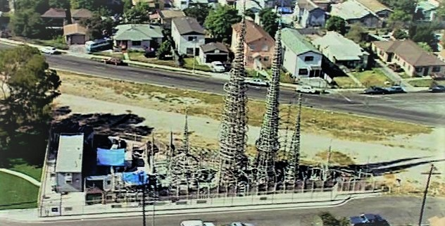
Under the pretext of enacting California’s “transit-oriented community” directive, the Los Angeles City Council allowed critically important public land to be sold off for private development and quietly fast-tracked approval of five- and six-story “affordable” housing projects that literally and visually will split the Watts community in two.

Among the projects that will further inflate the community’s already 136% population density is a five-story development along the Metrolink tracks (once the Pacific Electric Railway’s “Red Car Line” and a spur of the Southern Pacific Railroad). It will wipe out the view from the tracks of the world-famous masterpiece of “outsider art”, the Watts Towers – both a National Historic Landmark and a California State Park – and alter and dwarf the 103rd Street Watts Train Station, built in 1904 and on the National Register of Historic Places.

Called the “Hub” in the 1920s, this visible link between Towers and Station – a bare 10-acre crescent-shaped area – is the geographic center of Watts. Since the ‘60s, residents and visitors have called for this open space to be a green park for the diverse and underserved community. Betraying the long-held desire for green space in the center of Watts, the city government has distanced its residents from the process of protecting and enhancing Watts’ history and culture.

If built, the planned housing will choke off access between and to the community’s only two official historic preservation sites. It will also spoil the appreciation of a monumental work of architectural sculpture, Watts’ only major tourist destination, and undermine the State of California’s nomination of the Watts Towers as a UNESCO World Heritage Site.

The Towers were created single-handedly over 30 years by Italian immigrant Sabato “Simon” Rodia – he called them Nuestro Pueblo, “Our Town”. When Rodia started building in 1921, he wanted the view from the tracks to display his envisioned 100-foot tall mosaic-covered spires rising over their environment, greeting neighbors and visitors, now as it has for over 80 years. In 1959, they were brought to the world’s attention as a work of engineering and artistic genius when the Committee for Simon Rodia’s Towers in Watts saved them from an official City demolition order.

During the 1965 Watts Uprising, the Towers were protected by a community that adopted them as their beacon of freedom, their own “Statue of Liberty”. In 1985, activist Lillian Mobley founded the Watts Towers Community Action Council (WTCAC) to oversee the development of the bare space linking Towers and Station through its Watts Cultural Crescent Project. Attracting wide-spread community involvement with well-publicized and well-attended presentations and discussion groups, the WTCAC presented to the City in 1994 its Cultural Crescent Master Plan with designs for a cultural green park. The City never created the park, but some Plan features were later installed in unsuitable locations on site without consulting the community.

After the City’s Community Redevelopment Agency was dissolved in 2012, the property along the tracks was transferred to the County of Los Angeles with the stipulation that the natural connection between Towers and Station be preserved. But, in 2018, without public knowledge, the County sold the land and the Station to the non-profit Housing Corporation of America (HCA). Only a select few in the community knew of it until June 2020, when the sale was casually noted by a City official during a Watts Neighborhood Council meeting.

Recently, on February 21, 2021, during a special Planning and Land Use Committee meeting of the Watts Neighborhood Council, a broad range of community residents, stakeholders and cultural organizations questioned officials of the Housing Authority of the City of Los Angeles (HACLA) about the legitimacy of the process by which the City Council approved the housing developments in Watts.

Since 2018:
- The City has let HCA’s profit-making affiliate, Thomas Safran and Associates, design what will be the tallest structures in Watts – including a 96-unit 5-story housing project along the tracks by the 103rd Street Train Station;
- HACLA and the 15th District City Council office have made only partial disclosures of specific plans for this and other housing developments to various community members and stakeholders in poorly announced meetings; and
- with direct engagement limited by the pandemic, the City has failed to give adequate notification of public hearings that allowed the City Council to exempt these projects from environmental review as mandated by the California Environmental Quality Act; with the highest rate of pollution in Los Angeles, Watts has a long, well-documented history of environmental hazards, especially along its railway embankments.

These projects, including plans to tear down and replace the Watts Happening Cultural Center, built in 1970 (which housed Budd Schulberg’s Watts Writers Workshop and the Mafundi Institute), represent a process that consistently ignores legal precedent and excludes concerned community residents and stakeholders from contributing to plans that directly affect their own future. The City’s pretense of community engagement while erasing the history of communities of color aptly describes the first steps of “gentrification”.

In 1959, a local, state, national and international coalition stopped the City of Los Angeles from tearing down the Watts Towers. Today, seeking to encase the Towers in a vapid urbanized box and destroy a major cultural landscape, the City will once again become a global laughingstock.

